**How to get the website on your GitHub account**

* Log in to your GitHub account
* Once you are logged in, go to https://github.com/displayai/zakariya
* Click “Fork”
* Once prompted, name the repository to be Zakariya
* Done

**How to make code changes:**

* Click download Zip
* Unzip the file
* Open “index.html”in a web browser
* To make code changes, edit “index.html” it notepad, a code editor etc., and press control + s after code changes and refresh index.html”in a web browser
* Once you are happy with the code changes, you need to update the “index.html” file on your GitHub account
* To do this go to GitHub account then “index.html”
* Click on the edit icon

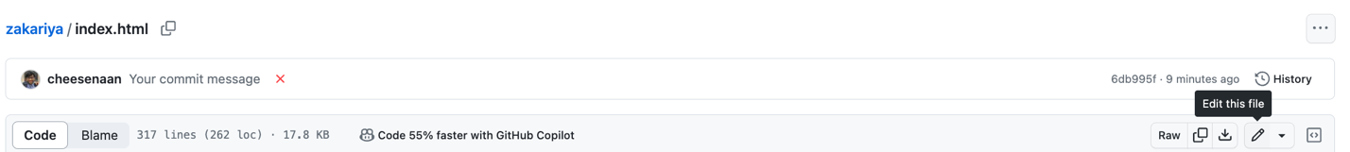

* Replace the contents of the file with the updates code
* Commit changes

**How to deploy website on GitHub pages**

* Click on Settings

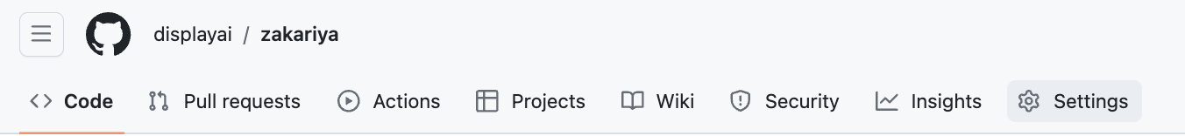

* Click on pages

* Select branch to be “main” then click save
* Wait around a minute and your site will appear at the top

**Re-deployments**

If your site is already built, and you made code changes, click on “deployed”

Then click “re-run all jobs” on the top right

